User Manual –
- CF Timesheet
- Timesheet for Cross Charge
- Cross Charge Processing

Document Version 1.0 and Date 01st March 2012
By IIS – ePMO team

Table of contents
Table of contents 2
1.1 Login Details 3
User Access 3
Menu Item 4
1.2 Menu Option descriptions 4
1.3 Timesheet Entry 4
Steps to view the Timesheet data Entered 7
Timesheet Approval 7
1.4 TimeSheet Report 8
1.5 Consolidated Report 9
1.6 Approve-Reject/View Cross Charge 10
1.7 User Manual 10
1.8 Session Details 10
2 Document Amendment History 10

Login Details

User Access
To access the applications – ‘Masteknet → Applications → Project Delivery → …’
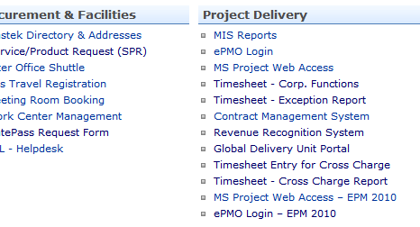

- Users belonging to Corporate Functions or Cost Centres can access CF Timesheet Application using link “Timesheet – Corp. Functions” to fill in the timesheet for their own unit
- Users belonging to projects / WBS and Corporate Functions/Cross centre will use this timesheet application only for Cross Charge purpose. The link for the same is “Timesheet entry for Cross Charge”
The regular timesheet would be continued as per projects requirement. Once the Cross charge timesheet is entered, it would be sent for approval and would be processed (accept/reject) by the recipient unit head (Recipient Unit is the unit for which the services were rendered for, by the Source Unit).
- Units Heads / authorized personnel by Unit Heads, can use link “Timesheet - Cross Charge Report” to process the cross charge entries or to view the report.

Menu Item
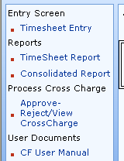

Menu Option descriptions
  - Timesheet Entry
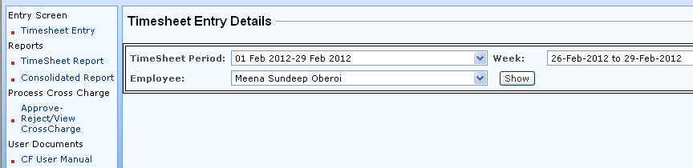

- Selection of the Timesheet Period

- Timesheet Period dropdown displays all the months (current and previous). Timesheet can be entered only for the current week/month; the previous ones will be shown as freezed.
- The timesheet can be entered for the current month till the monthly processing and the month freeze that happens in the next month.
- Current month is displayed by default.
- User is allowed to select any of the Timesheet Months.

- Selection of the Week

- In case the Timesheet Month is the current month
  - Current and previous weeks will be available for selection in the dropdown
  - Current week will be displayed by default.
- In case the user selects a different Timesheet Month
  - All the weeks of the selected month will be displayed in the dropdown
  - First week of the said Timesheet Month would be displayed by default.
- User will be allowed to select the week for the said Timesheet Month.

- Employee Name
- In case a supervisor logs in
  - All the resources reporting to him will be displayed in the drop down
  - Logged in user name will be available by default
  - User can fill timesheet for self
  - User can view the timesheets filled by his sub-ordinates but cannot edit their timesheet.
  - Button will be shown to ‘Approve’ the timesheet for the team members.
- 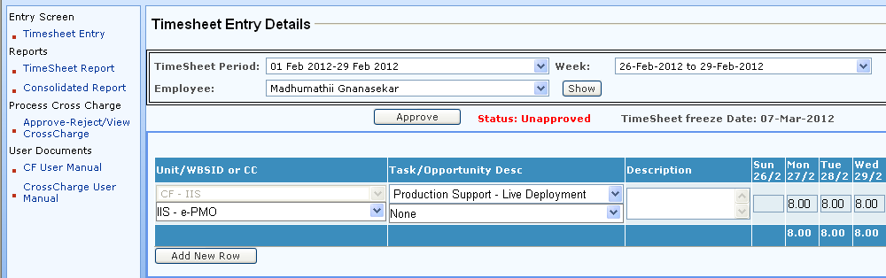
- In case logged in user is not a supervisor
  - Employee Name option will not be available
  - User can fill timesheet for self

- Selection of the Unit
- First column, first drop down – list of Units (Geo, VC and CF) will be displayed
- The Unit to which the user belongs will be displayed as the default value.
- User can select a different unit if the timesheet is to be filled for any task carried out for that unit.

- Selection of the WBS ID or CC
- First column, second drop down - WBSID or Cost Centre (CC) will be displayed for the select Unit in the first drop down.
- In case the user selects his/her own Unit (i.e. does not select a different unit), then the default value will be his/her own Cost Centre / WBS.
- When the user selects any other unit (CF / Geo) then all the active Cost Centres belonging to the selected Geo/CF will be displayed in the drop down. The timesheet entered for any CC other than his/her own, will be considered for Cross-Charge.
- When the user selects any other unit (VC) then all the active Cost Centres and WBS belonging to that VC will be displayed in the drop down. The timesheet entered for any WBS/CC other than his/her own, will be considered for Cross-Charge.
- User will be allowed to enter the WBS Description or Cost Centre description, as applicable, against which he has to fill the timesheet.
- To type the description, clear the contents of the dropdown and start typing. The box below will list all the matching entities to select from.

- Task Selection
- Second column, first drop down – Task list applicable to the unit to which the resource belongs to, will be displayed. This task list is as per provided by respective unit.
- The resource entering the timesheet will select a task to log the time.
- Note: Every Unit will have a separate task list depending upon the corporate function they perform.
In case the relevant tasks are not available, please get in touch with your supervisor and send those activities to MSP Support (mspsupport@mastek.com/ IIS Support) with an approval of your supervisor.

- Selection of Opportunity Description from salesforce.com
- Second column, second drop down – List of opportunities specific to VC from salesforce.com will be displayed in the dropdown.
- These are Opportunities with probability => 0 & <=100% and excluding those where stage is “Lost” or “Hold”.
- User can either select from the list or type in the text to search for a specific opportunity.
- This is an optional field.
- Entry of Activity Description
- In this step the person entering the timesheet will enter a brief description of the task performed.
- This is not a mandatory field.
- Time Entry
- The user will enter the time either for part of a working day, for the day or for multiple days in a week.
- The timesheets can be filled only for the open timesheet period.
- In case the month and the week selected is the frozen timesheet period, the timesheet data cannot be edited.
- Enter the efforts in timesheet standard.
In case the user has worked for 1hour 15 minutes, enter 1.25; 1 hour 30 minutes, enter 1.50; 1 hour 45 minutes, enter 1.75
- In case the user has worked on different tasks with in a day, he will have to enter those on different rows by selecting the appropriate tasks on different rows and filling in the efforts against those activities on the concerned day.

- Add New Row
- In case the user wants to add timesheet for some additional tasks, then the user can add an additional row using ‘Add New Row’
- Save
- This is the final step, where the user has to save the timesheet entered. On click of Save, user can see the following message:
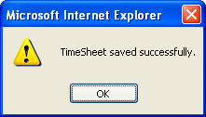

- Send For Approval
- Once the timesheet is saved user will have to send the timesheet for approval.
- Click on ‘Send for approval’ button
- When the resource clicks on ‘Send for Approval’ button, an auto mail is sent to the supervisor with the details of the timesheet entered. Also mentioned is the URL where the supervisor can click to approve those timesheets.

Steps to view the Timesheet data Entered
- As mentioned in ‘Steps for Timesheet entry’ the user can select the timesheet month, week and employee and click on go.
- All the timesheet data entered will be displayed on the screen.
- In case the month and the week selected is the frozen timesheet period, the timesheet data cannot be edited.

Timesheet Approval
- To approve the timesheets supervisor will have to login in the Timesheet Entry Screen
- User can select the month and week for which the approval has to be done.
- Select the Employee name whose timesheet has to be approved.
- Click on ‘Show’.
- The timesheet data for the selected employee will be displayed.
- Status of data will be displayed as ‘Unapproved’
- To approve the timesheet, click on ‘Approve’ button.
- This will approve the timesheet and show the status as Approved

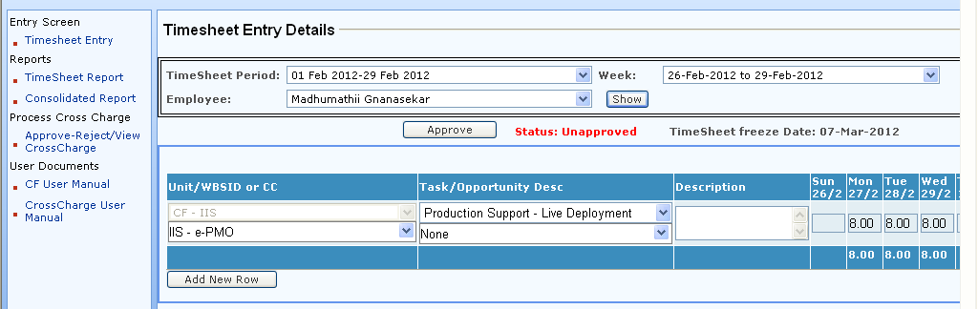

Note:
- Same screen is used for timesheet entry as well as approvals by the supervisor.
- Selecting his own name will allow the supervisor to enter timesheet data.
- Selecting the sub-ordinates name will allow the supervisor to approve the timesheets filled by them.

  - TimeSheet Report

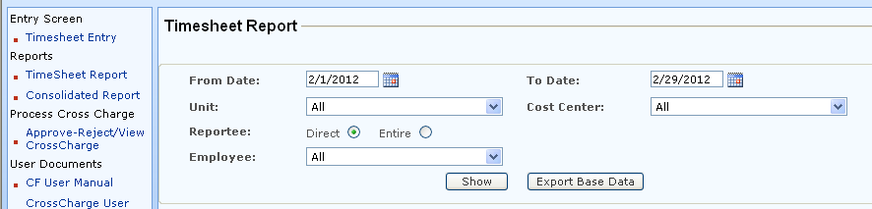
- Efforts report extracts the employee timesheet entry details in excel based on the selection criteria.
- This report is accessible only to Supervisors of/in Cost-Centres or those supervisors who have subordinates in Cost-centre (who fill timesheet in Corporate functions Timesheet).
- An external employee can also be given rights to view efforts report for any specified supervisor.
The report can be fetched for your own unit (as a Source Unit). The report format is as given below:
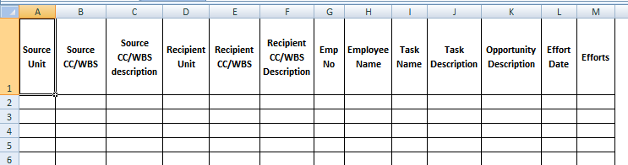
  - Consolidated Report

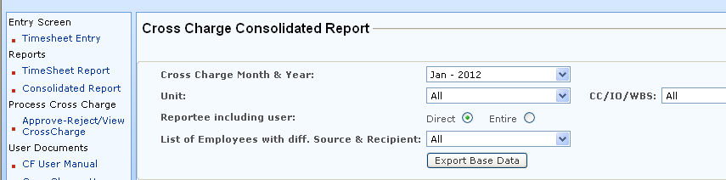
The purpose of this report is to get the status of the timesheet filled w.r.t Cross Charge.
- Cross Charge Month & Year: Only the month for which the Cross Charge calculations are done, will be shown in this drop down.
- User can select the Unit & CC/WBS for which the report is to be generated.
- This report is accessible only to Supervisors.
- Selecting ‘Direct’ option will list only the direct reportee to the logged in user. To view all reportee for the selected month, select option ‘Entire’.
- ‘List of Employees with diff. Source & Recipient’ drop down will list the employees who have filled in the timesheet for any other unit (CC/WBS). The employees which have filled in the timesheet for unit where they allocated to, will NOT be listed here.
- The employees shown in the above drop-down are ‘eligible’ for Cross Charge.
- The report gives the status of such ‘cross-chargeable’ efforts as either – Accepted/Rejected/Auto-approved or Less than 40 hours.
- The entries having status as Accepted / Auto-approved, will be calculated as Cross Charge.
- The data can be fetched in Excel and pivots can be inserted based on the base data.
- Report format is as attached here…
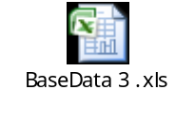

  - Approve-Reject/View Cross Charge
Refer attached document.

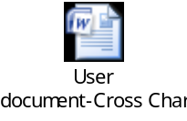
  - User Manual
Refer this document.

Session Details
- Session expiry time is 45 Minutes.
- If you keep the page open for 45 minutes without any activity you get an alert.

Document Amendment History
Issue | Date | Author / Editor | Reviewer | Details of Change
1.0 | 1st March 2012 | Meena Oberoi | Sandeep Yalgi | Final Version

